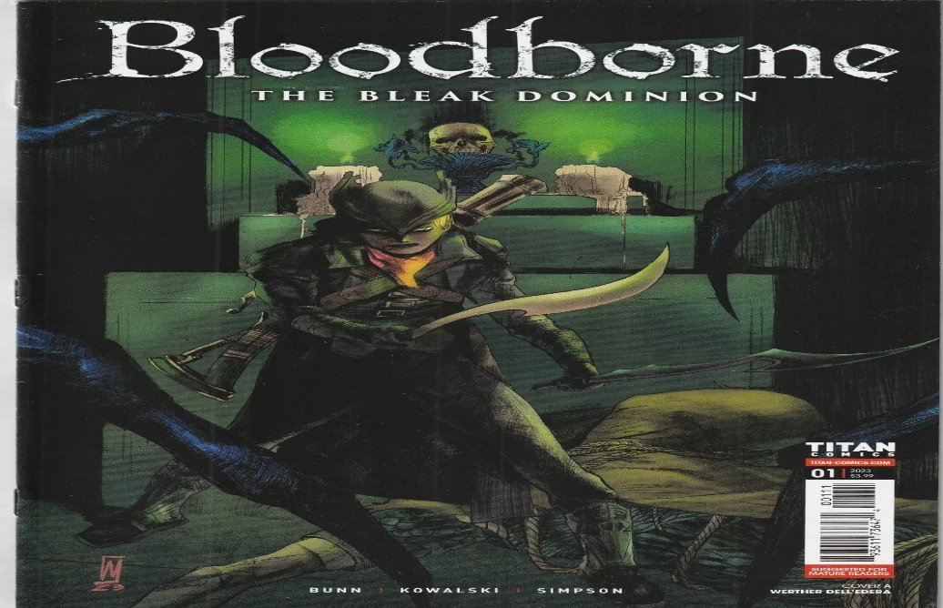

Bloodborne:

**1️.Fast & Aggressive Combat**

Encourages **aggressive play** with **no shields**, a **Rally System** to regain health, and **quick dodging mechanics**.

**2️. Unique Trick Weapons & Firearms**

Weapons **transform** for **dual fighting styles**, and **firearms replace shields**, allowing **parry-based counterattacks**.

**3️. Gothic & Lovecraftian Horror Setting**

A **dark, eerie world** blending **Victorian gothic horror** with **cosmic, eldritch nightmares**.

**4️. Challenging Bosses & Enemies**

Features **terrifying, multi-phase bosses** like **Father Gascoigne, Ludwig, and Orphan of Kos**, with grotesque enemy designs.

**5️.The Old Hunters DLC Expansion**

Adds **new areas, weapons, and bosses**, expanding the **lore of the Healing Church and nightmare realms**.